# NinthAve VECTCOLOR copy 2hi res.pdf

**CALL FOR ARTISTS & PROSPECTUS**

**Snow Goose Festival Wildlife Art Exhibit**

January 27 to February 12, 2016

**Opening Reception: Friday January 29, 5-8 pm**

# This art exhibit is part of the Snow Goose Festival 2016 that will take place from January 27 to 31, 2016.

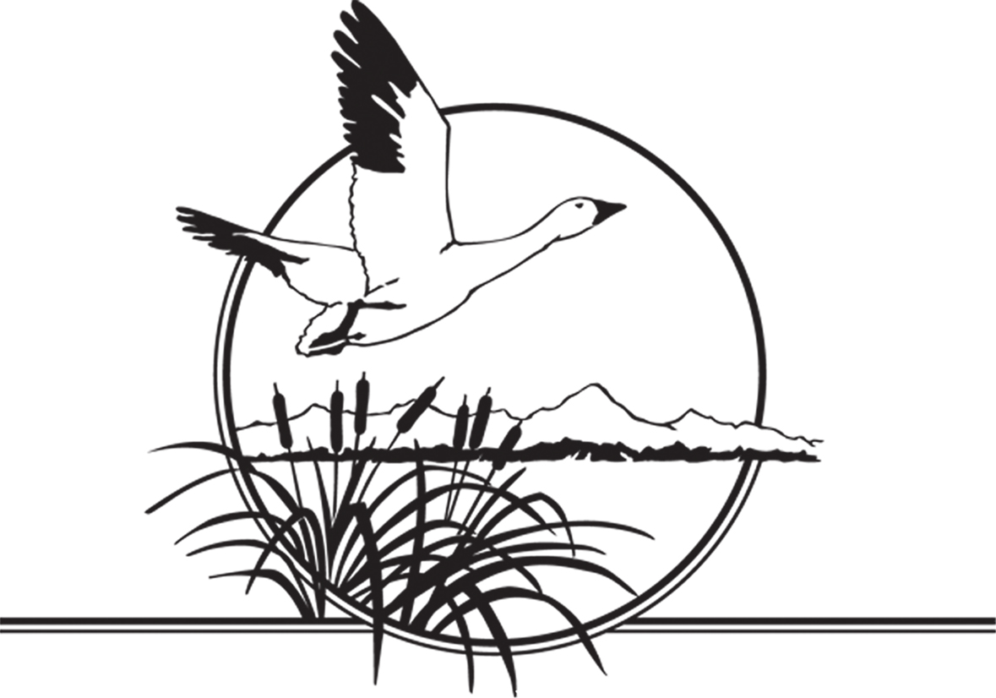

**Call for Artists**

Artists whose subjects include wildlife and habitat along the Pacific Flyway, North and South, are invited to submit artwork for a juried exhibition to take place during Chico’s 2016 Snow Goose Festival in its 17th year. All media will be considered. A jury consisting of art and nature experts will make the final entry choices and will issue special commendations during the exhibit.

The wildlife exhibit will be held at 215 Main Street, Chico from Wednesday, January 27, through Friday, February 12, 2016. The formal opening reception is **Friday January 29 from 5 to 8 pm.** The reception is a free event for the community at large.

For all other festival events, activities and schedules please go to the Snow Goose Festival’s official web site, [www.snowgoosefestival.org](http://www.snowgoosefestival.org).

**Submission Guidelines:**

**(Application Deadline: December 30, 2015)**

Accepted applicants will have at least one work in the show. New work will be given special consideration. All work in the show must be for sale. Artists whose work is chosen to be in the exhibition agree to have the work available for exhibition and for sale during the exhibit. A portion of the proceeds will be donated to the Snow Goose Festival.

**Application Requirements:**

**1. Images**

* Email your images to [csexton19@gmail.com](mailto:csexton19@gmail.com). High-resolution files (300 dpi, 6” at the greatest side) will allow us to use them for print publicity.  If low-res, send 72 dpi images at least 8 x 10".
* If on a cd, send to Ninth Avenue Gallery, 180 E. 9th Avenue, Ste. 1, Chico, CA 95926.
* Identify your images like this: Your last name and number of submission (smith1.jpg, smith2.jpg etc) to match your image list description (See below, #2). The name of the image file MUST match the name on the image list.

**2. Image List, prices, descriptions:** This list contains the information for the labels.

* An image list with the titles corresponding to your images, as in the following example:

Smith #1: a) Title, b) medium, c) size of image and size incl. frame, d) retail price, and optional, e) a brief description of the image to put on the wall.

* The price listed should include a 40% gallery commission.

**3. Statement and/or résumé**

* Include a résumé or c.v.; and/or
* A brief statement about how the images reference your response to the subject matter and your reason for making the images.

This information goes into the artist’s book that is made available to the public for viewing during the exhibition.

**4. Entry Fee: $25 (non-refundable) for 3 images; $5 ea for additional entries**

* Check, Visa, MC, or PayPal payment must be received upon entering;
* Make checks payable to Ninth Avenue Gallery and write Snow Goose 2016 in the memo. Your canceled check is your receipt;
* For Visa or MC, call or visit the gallery (530-318-2105); for Paypal (preferred for International entries), please send the payment to [csexton19@comcast.net](mailto:csexton19@comcast.net). These payments must be made within the week of application.

**Anticipated date for jury panel’s decision is January 15.** You will be notified immediately about which, if any, of your works are accepted.

**The work must arrive ready to hang.**

* Local artists’ selected works must be delivered to 215 Main Street, Chico Friday, Jan 22 between 4 and 6 or Saturday, Jan 23 between Noon and 3pm. Work that is shipped must arrive the week of January 18 thru 21 directly to the gallery.
* The work must be ready to hang. Pictures must be prepared for hanging with wire. **NO SAWTOOTH HANGERS ALLOWED**. Each work of art must be clearly identified so we may match your label information to the correct work.
* Nothing over 25 lbs. will be accepted. Two-D work may not be more than 36” x 48” frame inclusive.
* Artists who create three-dimensional works that do not hang on walls, and artists whose mediums require a computer display or other non-traditional display method should e-mail the gallery with a description of the specific needs before applying to the show.  We will let you know right away whether we can satisfy your display needs.

**Please note**: If you are not a local artist or if for any reason you must ship your work, return postage arrangements will be required up front. If the work does not sell, it will be re-packaged in its original shipping materials and sent back to you at your cost.

If shipping the work, please insure it. If glazed, make sure to use plexi-glass to prevent breakage since glass could damage the artwork. The gallery will not be held responsible for work damaged in shipment. For further information, please call Cynthia Sexton at (530) 318-2105 or email csexton19@gmail.com.

**Awards: Jurors’ Commendations and People’s Choice Award**

Once the show is hung, the Snow Goose Jury panel will award a number of Jurors’ Commendations with certificates of merit. In addition, there will be a People’s Choice Award; a modest cash award donated by the viewers who participate in the vote during the exhibit.

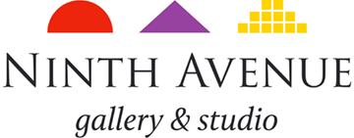

**Sign Up Sheet**

**Snow Goose Festival Wildlife Art Exhibit**

**DEADLINE TO APPLY: SATURDAY DECEMBER 30 5 PM**

Name

Address, City, Zip code, and Phone

Email

Signature Date

Number of images submitted Payment amount Pmt method

**CHECKLIST (Please make sure everything below is in your application package):**

1) Image List (with description) and prices_______________

2) Artist Statement and/or c.v. or résumé________________

3) Images (submitted on email is best) or on cd___________

4) Contact information (physical address & phone number in addition to email)

180 E. 9th Avenue, Chico, CA 95926, 530-318-2105

csexton19@gmail.com